Michelin Information Kit

This document, Importer Security Filing – Ocean Imports, applies to all suppliers providing goods to Michelin North America, Inc. under a Master Agreement for Services, Purchase Order or similar contract.


IMPORTER SECURITY FILING 10+2

2009 OCEAN IMPORTS REGULATION



INDEX

I. Glosary ……………………………………………… p. 4
II. Ten ISF Data Elements ……………………................ p. 4
III. Importer Security Filing Web Tool …………………….... p. 6
IV. Frequently Asked Questions ……………………………… p. 12

I. Glossary:

- ISF: Importer Security Filing
- CBP: Customs Border Protection
- IRS: Internal Revenue Service
- EIN: Employer Identification Number
- SSN: Social Security Number
- FTZ: Foreign Trade Zone
- MID: Manufacturer Identification
- HTSUS: Harmonized Tariff Schedule of the United States

II. The 10 data elements in the Importer Security Filing (ISF)

Legal Definition of the 10 elements in ISF:

- Seller name and address*: Name and address of the last known entity by whom the goods are sold or agreed to be sold. If the goods are to be imported otherwise than in pursuance of a purchase, the name and address of the owner of the goods must be provided.

- Buyer name and address*: Name and address of the last known entity to whom the goods are sold or agreed to be sold. If the goods are to be imported otherwise than in pursuance of a purchase, the name and address of the owner of the goods must be provided.

- Importer of record/FTZ applicant: Internal Revenue Service (IRS) number, Employer Identification Number (EIN), Social Security Number (SSN), or CBP assigned number of the entity liable for payment of all duties and responsible for meeting all statutory and regulatory requirements incurred as a result of importation. For goods intended to be delivered to an FTZ, the IRS number, EIN, SSN, or CBP assigned number of the party filing the FTZ documentation with CBP must be provided. The importer of record number for Importer Security Filing purposes is the same as ‘‘importer number’’ on CBP Form 3461.

- Consignee number(s): Internal Revenue Service (IRS) number, Employer Identification Number (EIN), Social Security Number (SSN), or CBP assigned number of the individual(s) or firm(s) in the United States on whose account the merchandise is shipped. This element is the same as the ‘‘consignee number’’ on CBP Form 3461.

- Manufacturer (or supplier) name and address*: Name and address of the entity that last manufactures, assembles, produces, or grows the commodity, or name and address of the supplier of the finished goods in the country from which the goods are leaving. In the alternative, the name and address of the manufacturer (or supplier) that is currently required by the import laws, rules and regulations of the United States (i.e., entry procedures) may be provided (this is the information that is used to create the existing manufacturer identification (MID) number for entry purposes).

- Ship to name and address*: Name and address of the first deliver-to party scheduled to physically receive the goods after the goods have been released from customs custody.

- Country of origin: Country of manufacture, production, or growth of the article, based upon the import laws, rules and regulations of the United States. This element is the same as the ‘‘country of origin’’ on CBP Form 3461.

- Commodity HTSUS Number: Duty/statistical reporting number under which the article is classified in the Harmonized Tariff Schedule of the United States (HTSUS). The HTSUS number is required to be provided to the 6 digit level. The HTSUS number may be provided up to the 10 digit level. This element is the same as the ‘‘H.S. number’’ on CBP Form 3461 and can only be used for entry purposes, if it is provided at the 6 digit level or greater.

- Container stuffing location*: Name and address (es) of the physical location(s) where the goods were stuffed into the container. For break bulk shipments, the name and address (es) of the physical location(s) where the goods were made ‘‘ship ready’’ must be provided.

- Consolidator (stuffer) name and address*: Name and address of the party who stuffed the container or arranged for the stuffing of the container. For break bulk shipments, the name and address of the party who made the goods ‘‘ship ready’’ or the party who arranged for the goods to be made ‘‘ship ready’’ must be provided.

* DUNS number accepted to substitute for full name and address.
D-U-N-S® Number (Data Universal Numbering System) is a unique nine-digit sequence provided by D & B (Dun & Bradstreet) recognized as the universal standard for identifying and keeping track of over 100 million businesses worldwide. D-U-N-S Number assignment is free for all businesses required to register with the US Federal government for contracts or grants. More information available at http://fedgov.dnb.com or www.dnb.com

Maritime bill of lading number – was not included as one of the 10 elements by the US Customs. However, from the beginning US Customs indicated that this number will be the key data element they will use to validate a shipment. Without this number an ISF can not be submitted. In order for this number to be available to the exporters the majority of ocean carriers are now providing the bill of lading number as early as the booking confirmation.
IT IS IMPERATIVE that each shipper check with the ocean carriers and ensure that the bill of lading number will be provided at the time of booking. Once the number is received the ISF can most likely be filled given that the exporters have all the other required information. The maritime SCAC number is found at the beginning of the Bill of lading number. It is a 4 letter code used by the maritime carriers for identification.
III. Importer Security Filing Web Tool

Getting Started:

1) Access Rogers & Brown website:
(https://service.rogers-brown.com/service/IMPSECMICZ.pgm)

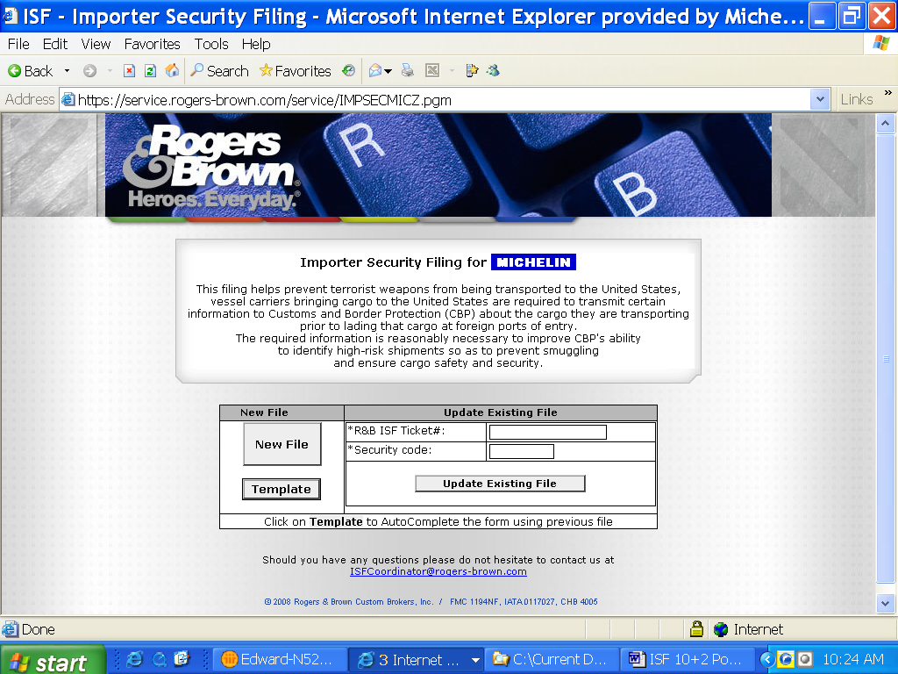
2) To start using the tool choose “New File” or if you are updating a file enter the information as requested.
*R&B ISF Ticket#: This number will be provided in an email from R&B once the entry is submitted.

*Security Code: Each Entry (ISF Filing) will have a Security Code assigned by the computer through the portal. This code will be emailed to the address that was previously keyed-in.

3) Filing the Entry:

Please use the following instructions to fill out the online screens (screens shown below):
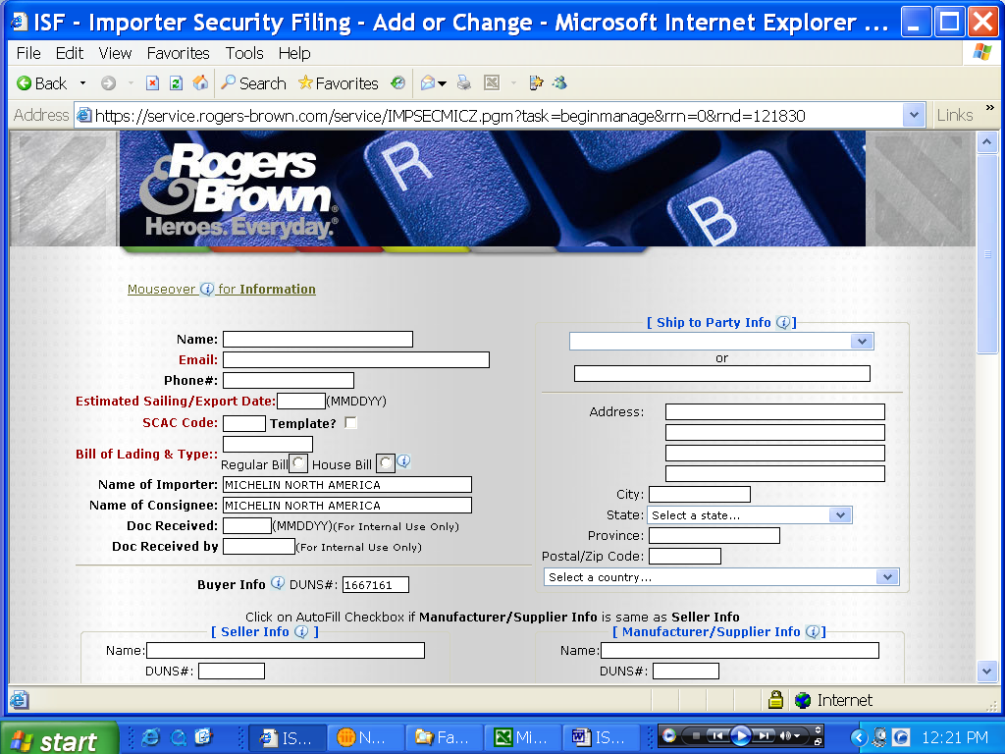
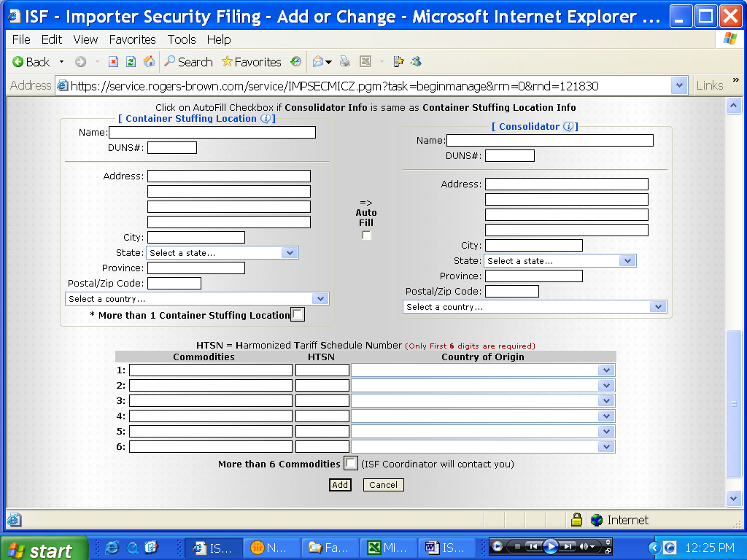

Name: This is the name of the person filing the ISF (for direct communication purposes related to the file only). Supplier is responsible to fill out.

Email: Email address where the Security Code will be emailed in order to later update/amend the ISF if necessary. Supplier is responsible to fill this out.

Phone #: telephone of the person or company filing the ISF (for communication purposes only, the US government will not see this data field). Supplier is responsible to fill this out.

Est. Export Date: Date of anticipated ship date from the port. Format as indicated. Supplier is responsible to provide. This helps ensure proper priority is given to the entry. This date should always be at least 3 days from the date this information is entered in the screen.

SCAC code: “Standard Carrier Alpha Code” – Maritime Company 4 letter code. Typically found at the beginning of the Bill of lading number.

Bill of Lading & Type: AMS filed or lowest house bill number (provided by the Steamship Line at booking time). This number can include both alpha and numeric and it is usually 12 digits or less. The ocean carrier or the forwarder should be able to provide the correct number. Choose between regular bill (bill of lading where there is no house bill filed) or house bill (typically found in shipments where a forwarder (NVOCC) is involved. In the later case the ocean carrier provides the forwarder a master bill as well.

Name of importer: Already filled out on the form as this will never change.

Name of consignee: Already filled out on the form as this will never change.

Doc Received: NOT FOR USE BY THE SUPPLIER.

Doc received: NOT FOR USE BY THE SUPPLIER.

Buyer Info: DUNS number for Michelin, already filled out on the form as this will never change.

Ship to Party: First deliver to party in the United States that is scheduled to receive the goods. Select the location from the drop down or if not there then fill out the information in the appropriate place.

Seller info: Name and address or DUNS number of the last known entity by which the goods are sold. ****If the Seller is the same as the Manufacturer/Supplier select “Autofill”. The system will automatically fill the same criteria for the Manufacturer/Supplier that was typed for the Seller.

Manufacturer/Supplier Info: Name and address or DUNS number of the company that supplies to the importer or manufactures the goods. Supplier and manufacturer can be the same of different but only one is to be supplied. . ****If the Seller is the same as the Manufacturer/Supplier select “Autofill”. The system will automatically fill the same criteria for the Manufacturer/Supplier that was typed for the Seller.

Container Stuffing Location: Name and address or DUNS number where the product/commodity was loaded into the container. **** If more than one stuffing location check the box marked “ * More than 1 container stuffing location”.

Consolidator: Name and address or DUNS number of the party that stuffed the container, or arranged for the stuffing of the container. ****If the Container Stuffing Location is the same as the Consolidator select “Autofill”. The system will automatically fill the same criteria for the Consolidator that was typed for the Container Stuffing Location.

Commodities: Description of the product being shipped (should be brief)

HTSN: Harmonized Tariff Schedule Number (only the first 6 are required) of the product shipped.

Country of Origin: Where the commodity being shipped was manufactured. ***Select from the scroll down list. If there is only one commodity but two different countries of origin make another line entry indicating the commodity and the country.

Once the form is completed click the Add button and the data will be sent to the ISF Coordinator (automatic email to ISFCoordinator@rogers-brown.com). If the box for more than 1 stuffing location was checked than a new window will open where you will again click the add button and fill in the information. Once completed click next and form is completed.

Use of Previously filed information

After completing the above steps the sender will receive an email containing two numbers:
1. R&B ISF Ticket #
2. Security code

When the supplier is ready to file another ISF they can reuse the information already submitted in the previous ISF.

Steps to do so:
1. Enter the received R&B ISF Ticket # and the security code on the first page of the URL then click the button “TEMPLATE”.
2. This will then bring up the particular shipment information less some of the fields that need to be updated.
3. Fill in the required fields and make sure that all the other information is accurate.
4. Click the “ADD” button and you will receive your confirmation email with the new numbers which you can then use at a later time.

If technical assistance is needed to use the Rogers & Brown web tool, or you have any questions about how to fill in the form, please contact ISFCoordinator@rogers-brown.com

Frequently Asked Questions:

- What is the Importer Security Filing?
U. S. Customs and Border Protection (CBP) will require a “Security Filing” for all containerized or break-bulk ocean cargo entering the United States. The Import Security Filing (ISF) also known as 10+2 is the Department of Homeland Security (DHS) strategy to better assess and identify high risk shipments, such as terrorist weapons and other dangerous materials and keep them from entering the USA.

- When will CBP be requiring an Importer Security Filing (ISF)?
Rogers & Brown has to send the complete and correct information (10 data elements) to CBP at least 48 hours prior to vessel loading at foreign ports, therefore, vendors are required to input their information in the portal at least 48 hours prior to vessel loading, thus allowing the broker to verify that the information is correct before sending it to CBP.

- When will it start?
The interim rule, known as 10+2, has taken effect on January 25, 2009. This is a period of trial to allow all companies to get ready to comply. The complete final rule will take effect as of January 2010.

- What are the 10 elements required in the Importer Security Filing?
Please see page 1 for complete definitions.

- Who can file the Importer Security Filing?
The importer or his agent (for Michelin, it is Rogers & Brown) will be responsible for filing the complete, accurate and timely Importer Security Filing. Michelin is requesting all its external suppliers for their support in helping us comply with this new regulation.

- How complicated will the process be?
For all Michelin external suppliers it will not be difficult because Rogers & Brown has already set up a system through their own website, to help in this process (see page 6 for instructions). This tool will allow all Michelin suppliers to upload their information in an easy way. As long as Rogers & Brown is provided with the required information they will coordinate as necessary with CBP.

- Are a Username and Password required to use the Rogers & Brown web tool?
No. The tool can be accessed directly from the Rogers & Brown website.

- Will the Importer Security Filing be required in all transportation modes?
The rule is focused on all ocean freight, whether it is container, bulk or other.

- Will there be any penalty about the new regulation?
As of January 2010, US Customs will apply fines of 5,000USD per bill of lading to the importer of record every time that non-compliance to this rule is registered.

For more information about the ISF 10+2 please visit:

http://cbp.gov/xp/cgov/trade/cargo_security/carriers/security_filing/

Contact Information:

- For questions related to the portal please send email to (please always include in copy the MICHELIN email address found below): ISFCoordinator@rogers-brown.com
- For Michelin related questions please email at: ISF.10plus2@us.michelin.com

